 | Assignment No. 02  Semester: Fall 2020  CS601: Data Communication |  | Total Marks: 20  Due Date: 15/12/2020
Instructions:
Please read the following instructions carefully before submitting assignment:
You need to use MS word document to prepare and submit the assignment on VU-LMS.
It should be clear that your assignment will not get any credit if:

- The assignment is submitted after due date.
- The assignment is not in the required format (doc or docx)
- The submitted assignment does not open or file is corrupt.
- Assignment is copied (partial or full) from any source (websites, forums, students, etc)

Objectives:

The objectives of this assignment are to learn about:
- Encoding Scheme
- Signal to Noise Ratio

Assignment

Question No. 1

Diagram given below is representing the Differential Manchester encoding scheme. You are required to carefully analyze the diagram and then write the binary pattern represented by the diagram:

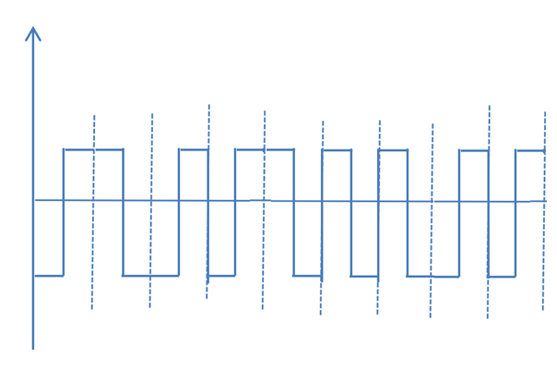
Hint: First bit is 0 and its voltage level is negative to positive.

Give your answer in the following table:

Question No. 2

Suppose a telecommunication company’s booster is emitting a signal of 0.45W, which is being passed through 10 devices. It has been observed that 7 of these devices are encountering noise of 3 microwatts whereas other 3 devices are encountering noise of 2 microwatts. Considering this information, you are required to calculate overall Signal to Noise Ratio (SNR) and SNR_{dB} by writing all necessary formulas and calculation steps.

Best of Luck!

